# Creating a WordPress Website

## Introduction

This is a how-to guide that goes through the steps taken to create the WordPress page that is being used as a prototype currently. It is important to note that there are multiple ways of achieving the same result. The method discussed in this guide is one of the simple methods that one can take in creating a WordPress page.

## Creating an Account for Hosting Site

First, it is important to set up a hosting site. The host used for the prototype is [000webhost](https://www.000webhost.com/) which is one of the many free hosting sites available. When you get to the site, there should be a Free Sign Up button either in the middle of the page or the top right corner of the page. Using your email, sign up for a free account.

After you have signed up for an account, check your email for a confirmation email. You must confirm before creating a website. When you click on the V*erify email* button in your email, it will take you back to 000webhost where an Email verified! message will appear.

## Starting a WordPress Site

On the top left corner of the page you're currently on, there is a *Build website* button with a picture icon. Click on it. This will then take you to a page with three big buttons in the middle: *Build a Website Easily, Build WordPress Website*, and *Upload Own Website*. Click on the *Build WordPress Website*. A pop-up will appear with the *WordPress install* header. Fill out the required information and press *Install*. 000webhost will then automatically create a WordPress site for you which you can view right away.

## Afterwards

### * How do I access the Admin page for my WordPress site?

* To access the admin page for the WordPress website, include */wp-admin* to the end of your URL (e.g. operationscl.000webhostapp.com/wp-admin) and log in using the admin login and password you set during the *WordPress install* popup.

### * My website is down! What do I do?

* Because 000webhost is a free hosting site, there are times when your website will be unavailable due to the free service. In addition, it is important to note that for all the sites created using a free account, ***there is an hour in which the website will go down***. However, you can set when the website will go down through 000webhost.

# Making Categories and Tags

## Introduction

This is a how-to guide that goes through the steps to make categories and tags on the WordPress site. Categories are mainly used for broad subjects that apply to multiple posts, while tags are more specific and apply to fewer posts. It is important to note that there are multiple ways of achieving the same result. To do the following steps, log onto an admin account for the WordPress website.

## Making Categories

On the side menu, hover over one of your post type denoted by the pin symbol. The *Posts* button is being hovered over, giving a sub-menu. (CatTagSS01) Click *Categories* in the sub-menu (CatTagSS01).

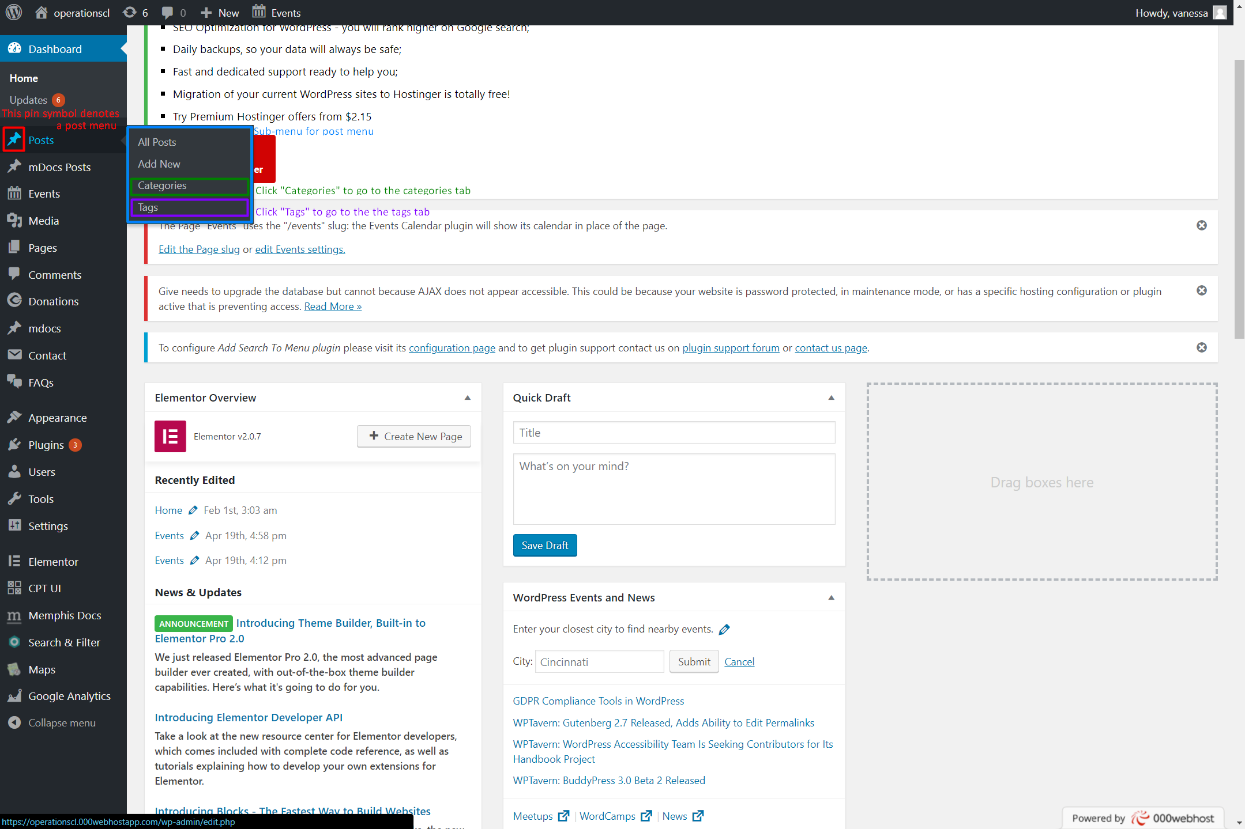

CatTagSS01

# Making Categories and Tags (cont.)

## Making Categories (cont.)

Type in the name of your new category under "Name" and a short version of the name for the url under "Slug" (CatTagSS02). If you are going to use the Search and Filter plugin for the site, it is probably best to leave the "Parent Category" as "None". You can make each category as a different form of posts on your website (ex. normal posts can be "Uncategorized" while posts from Memphis Docs can be "Archive", letting you filter between normal posts and Memphis Docs posts that contain archive content). You can add in a description for your category if you want to but it is not necessary. Hit "Add New Category" to make your new category.

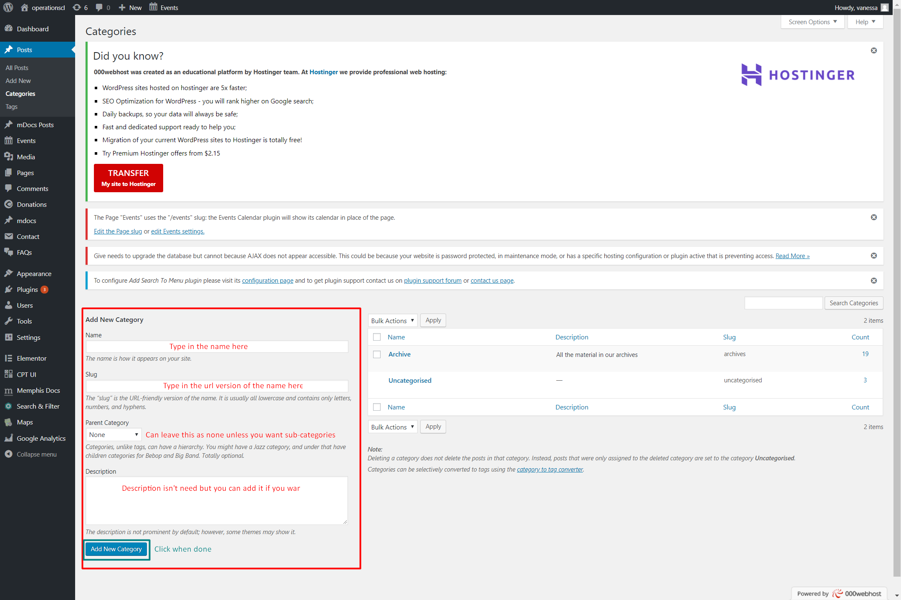CatTagSS02

# Making Categories and Tags (cont.)

## Making Tags

On the side menu, hover over one of your post type denoted by the pin symbol. The *Posts* button is being hovered over, giving a sub-menu (CatTagSS01). Click *Tags* in the sub-menu (CatTagSS01). Type in the name of your new tag under "Name" and a short version of the name for the url under "Slug" (CatTagSS03). You can add in a description for your tag if you want to but it is not necessary. Hit "Add New Tag" to make your new tag.

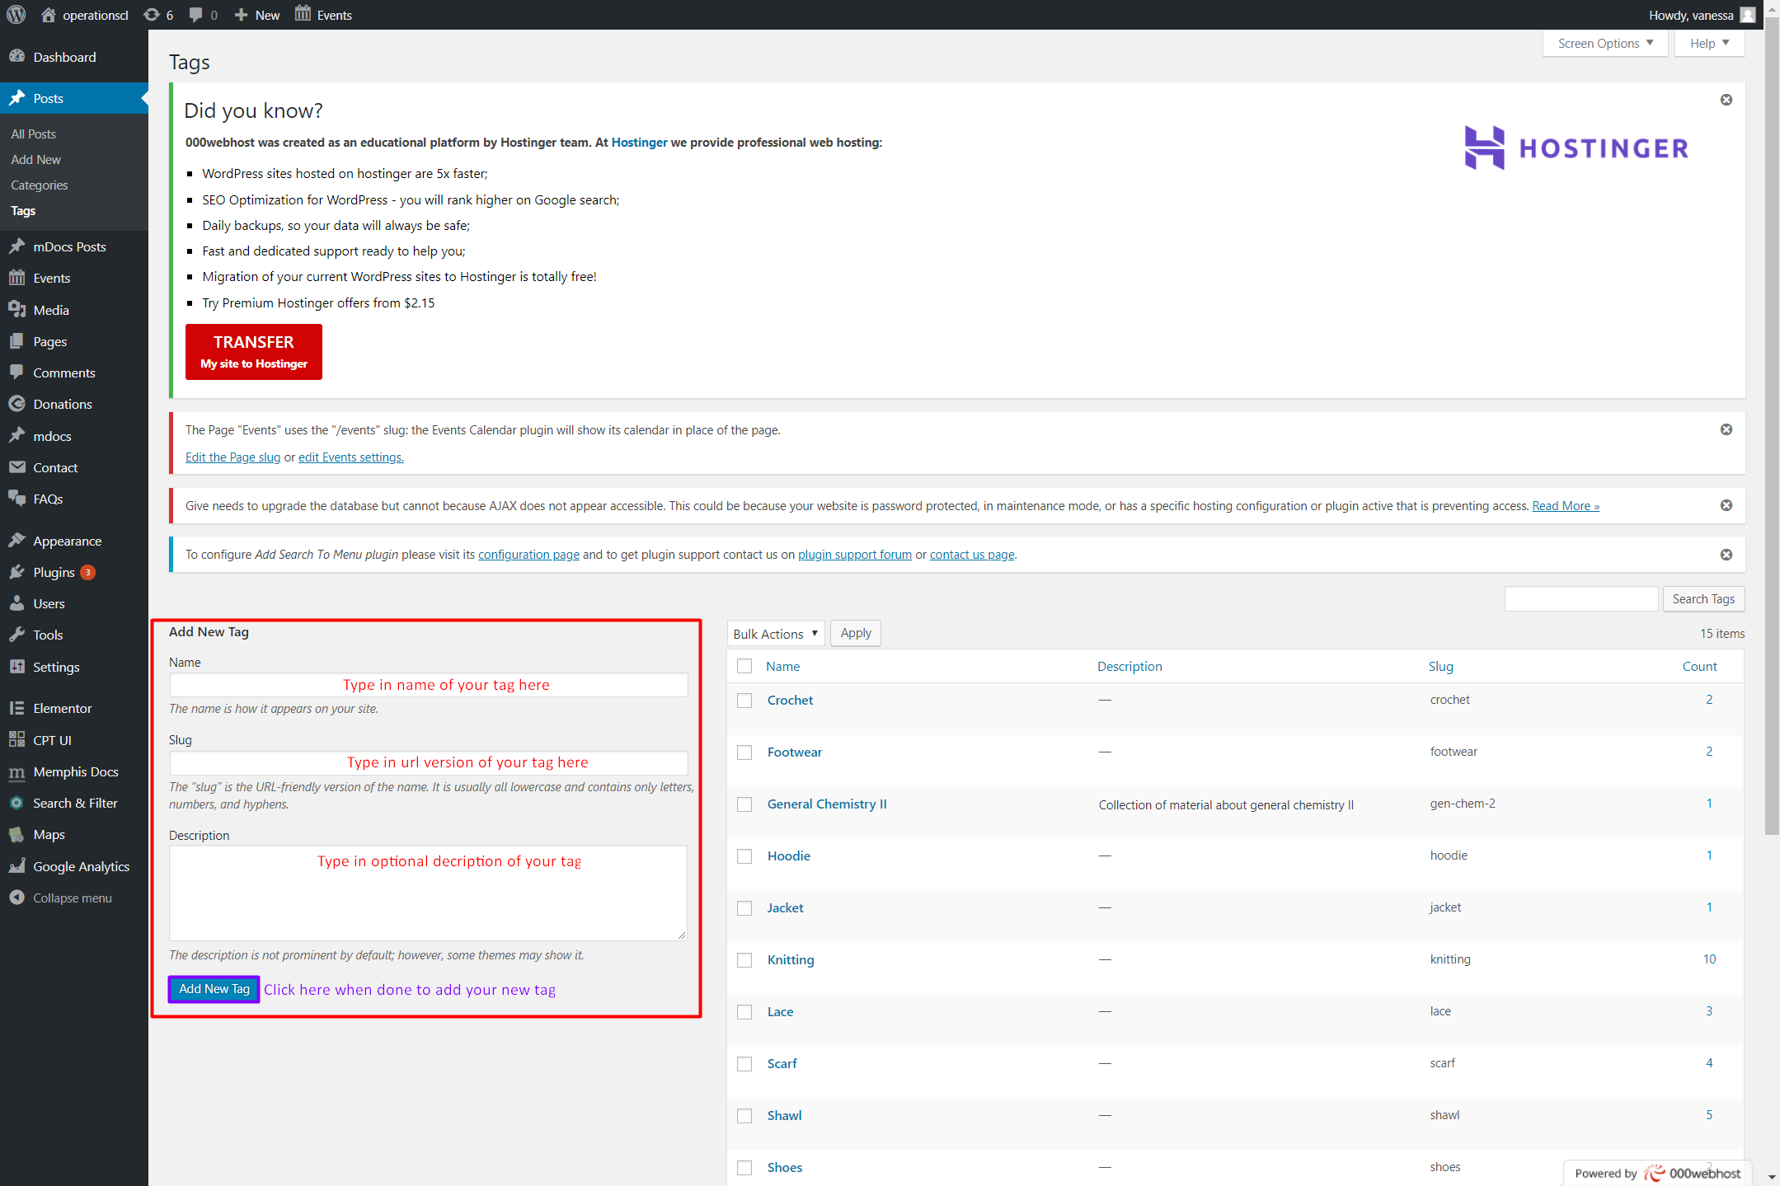

CatTagSS03

# Adding Plugins to WordPress

## Installation

The easiest way of installing a WordPress plugin is to use the plugin search. The only downside of this option is that a plugin must be in the WordPress plugin directory which is limited to only free plugins.

First thing you need to do is go to your WordPress admin area and click on Plugins Add New.

Find the plugin by typing the plugin name or the functionality you are looking for. After that, you will see a bunch of listing.

You can pick the plugin that is best for you and click the “Install Now” button.

WordPress will now download and install the plugin for you. After this, you will see the success message with a link to activate the plugin or return to plugin installer.

A WordPress plugin can be installed on your site, but it will not work unless you activate it. So go ahead and click on the activate plugin link to activate the plugin on your WordPress site.

That’s all, you have successfully installed your first WordPress plugin.

The next step is to configure the plugin settings.

## Configuration

### Add Search to Menu

Once you have the Add Search to Menu plugin activated, hover over *Settings* and click on *Add Search to Menu* (SearchMenuSS01).

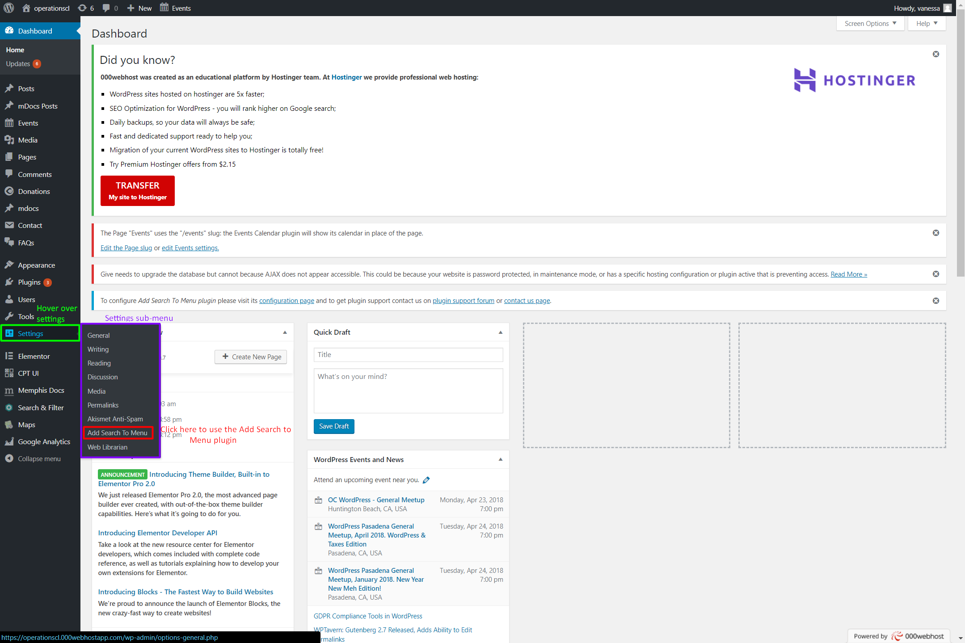

SearchMenuSS01

# Adding Plugins to WordPress (cont.)

## Configuration (cont.)

### Add Search to Menu (cont.)

Choose the menus you'd like the search bar to be on and the post types you want the search bar to search through when used (SearchMenuSS02). Click on *Save Options* when done.

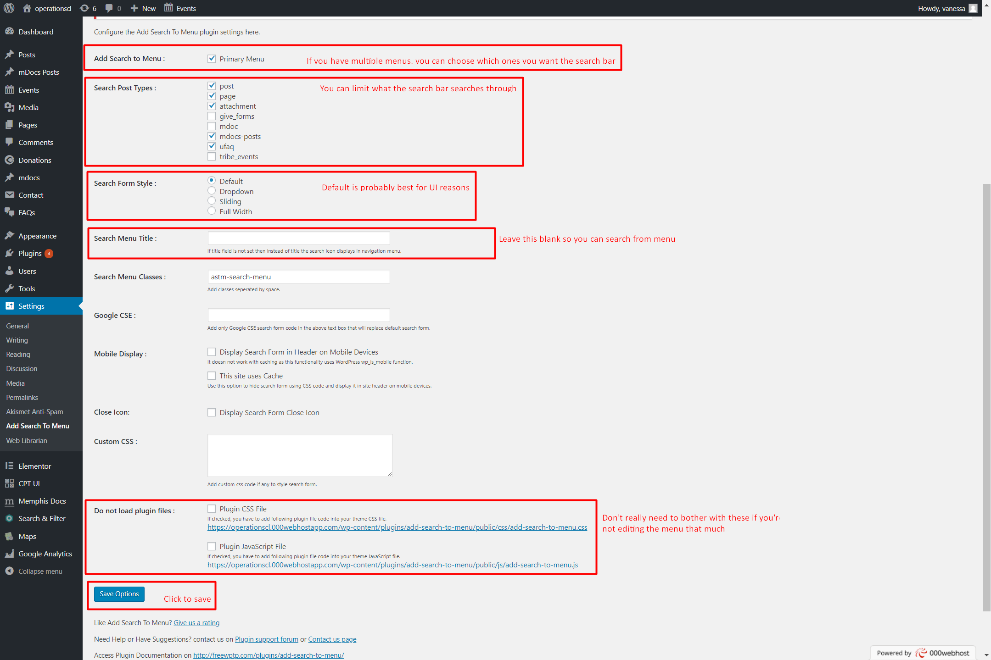  
SeachMenuSS02

# Adding Plugins to WordPress (cont.)

## Configuration (cont.)

### Give Donation Plugin

Go to the Give tab of your WordPress dashboard by clicking on *Donations*(GiveSS01).

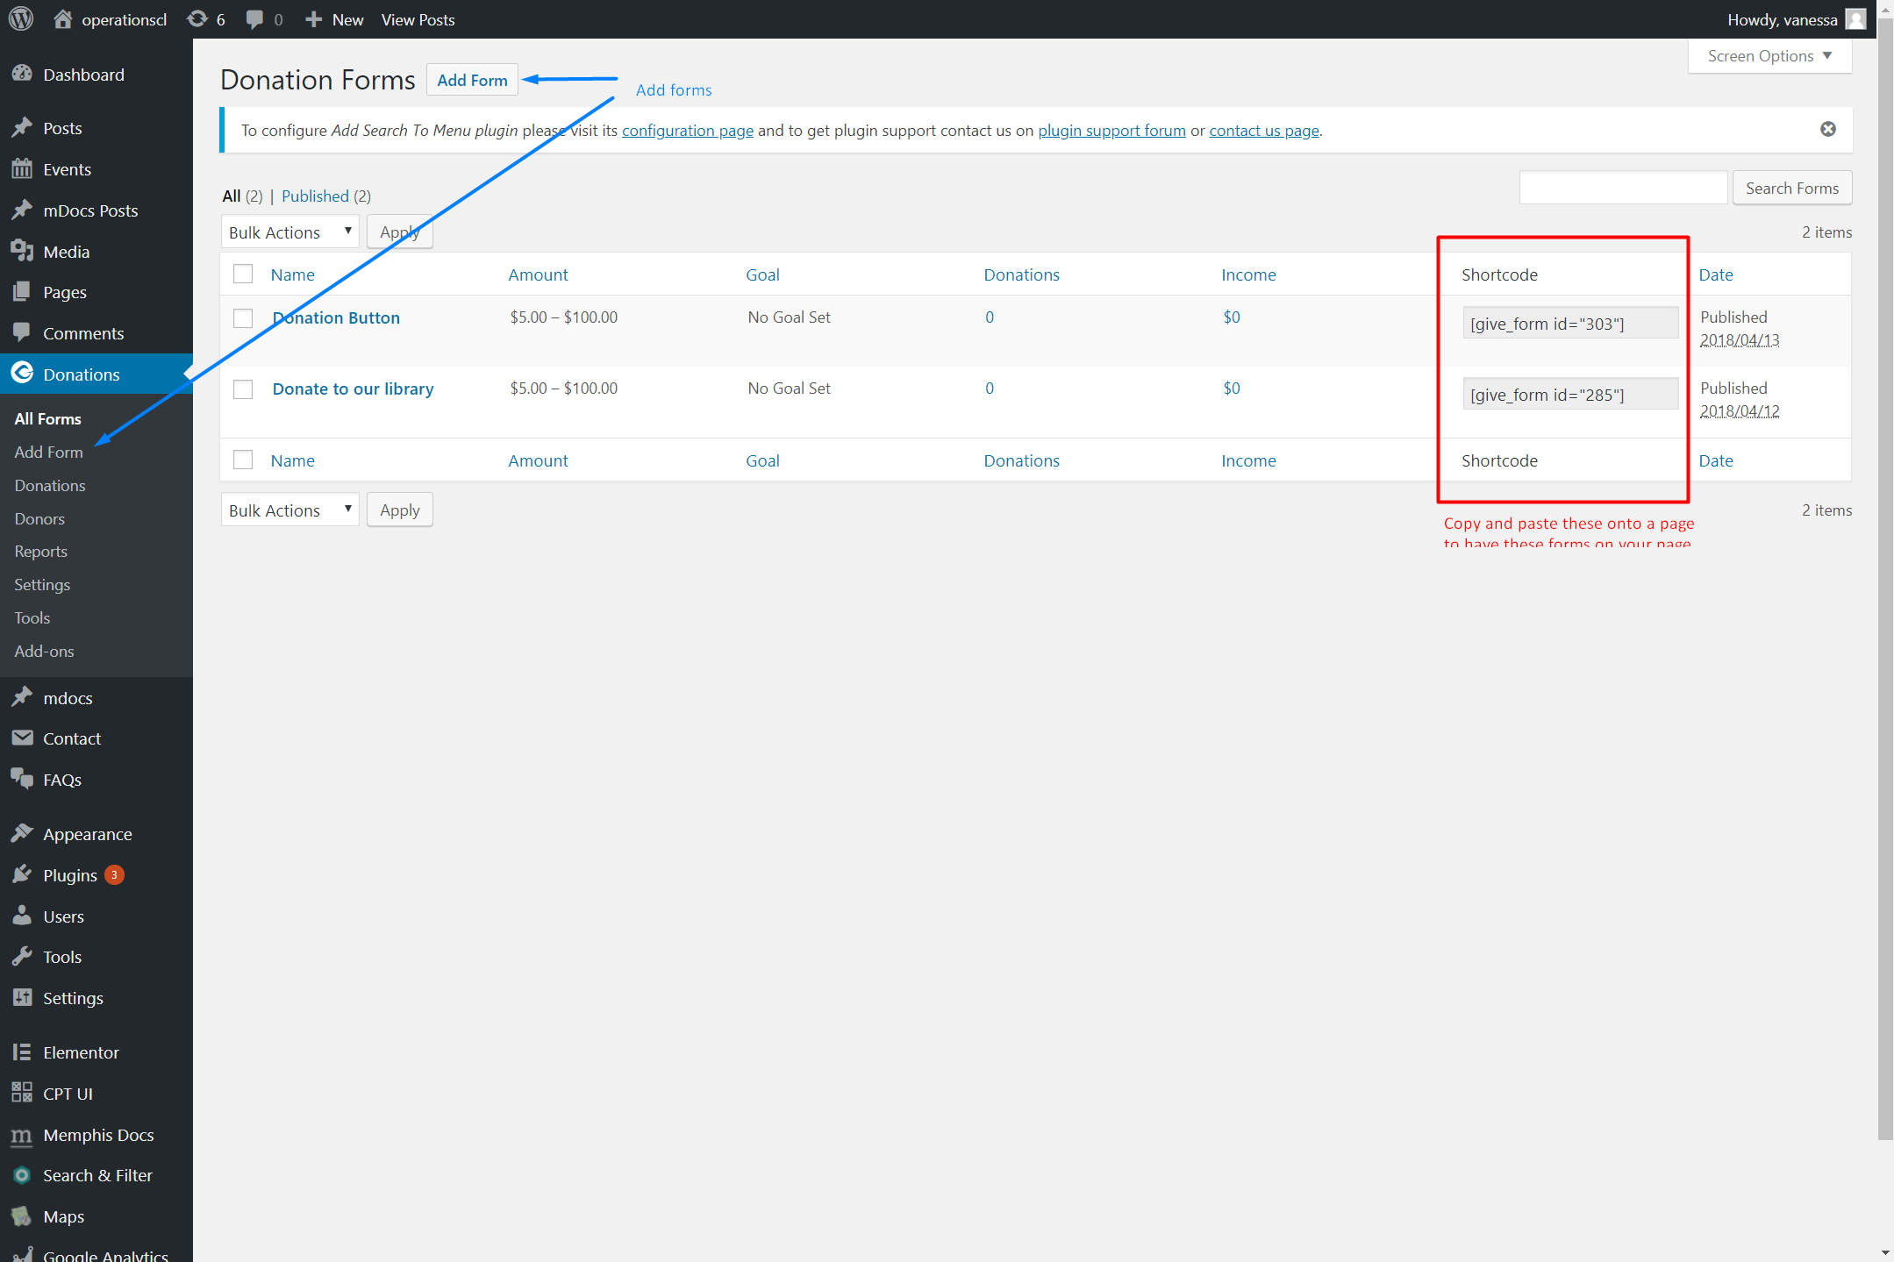

GiveSS01

# Adding Plugins to WordPress (cont.)

## Configuration (cont.)

### Give Donation Plugin (cont.)

You can edit and make your form with the settings provided (GiveSS02). Once you have made your first form, go to the *Settings* tab of your Give plugin (GiveSS02). Make sure to click *Save changes* after every change.

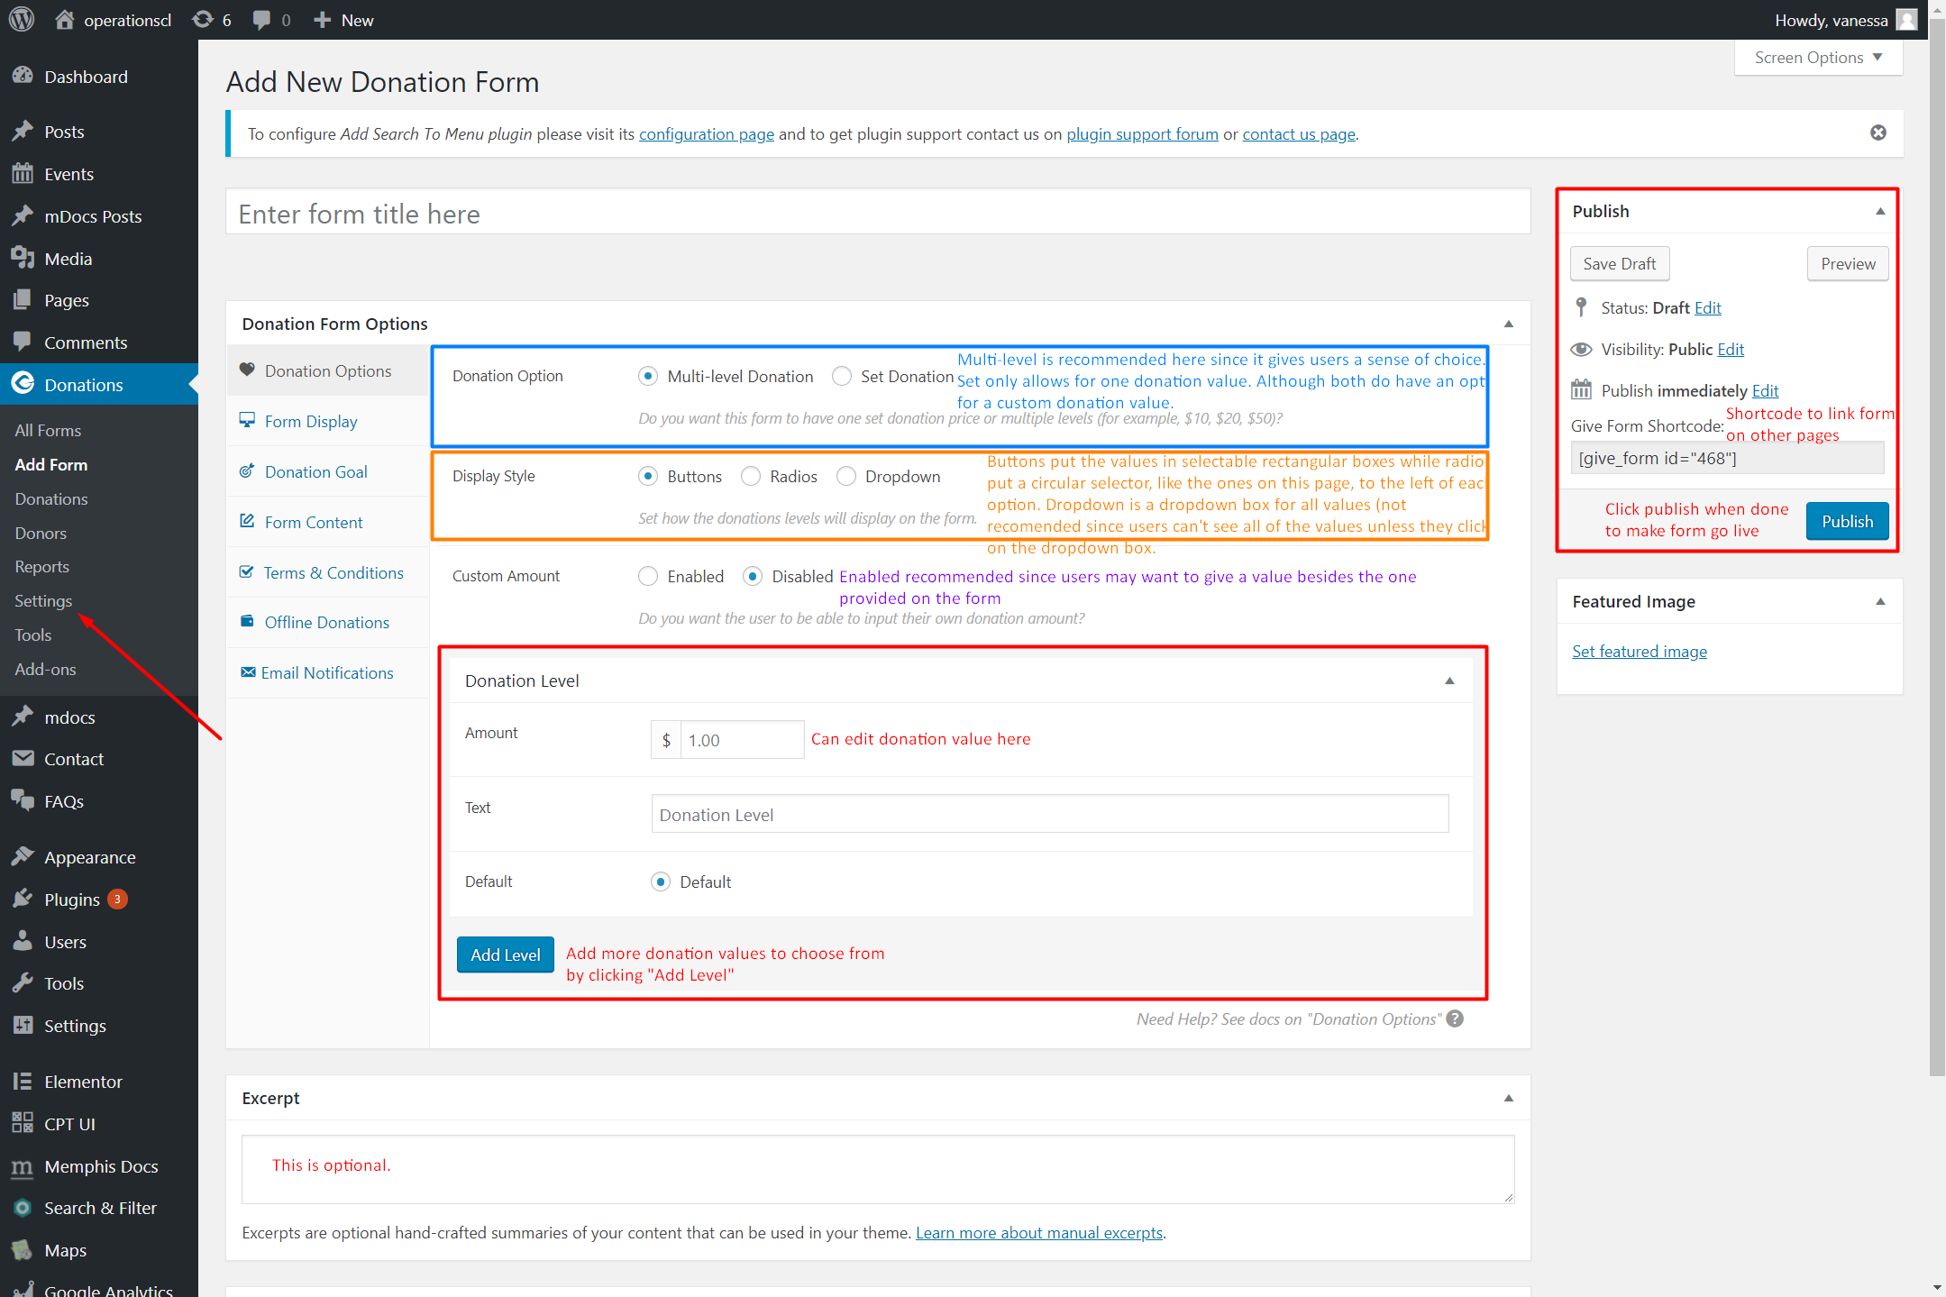

GiveSS02

# Adding Plugins to WordPress (cont.)

## Configuration (cont.)

### Give Donation Plugin (cont.)

The first page tells you what additional pages you need to make on WordPress for your plugin (GiveSS03). It will also give you the minimum content needed on each page.

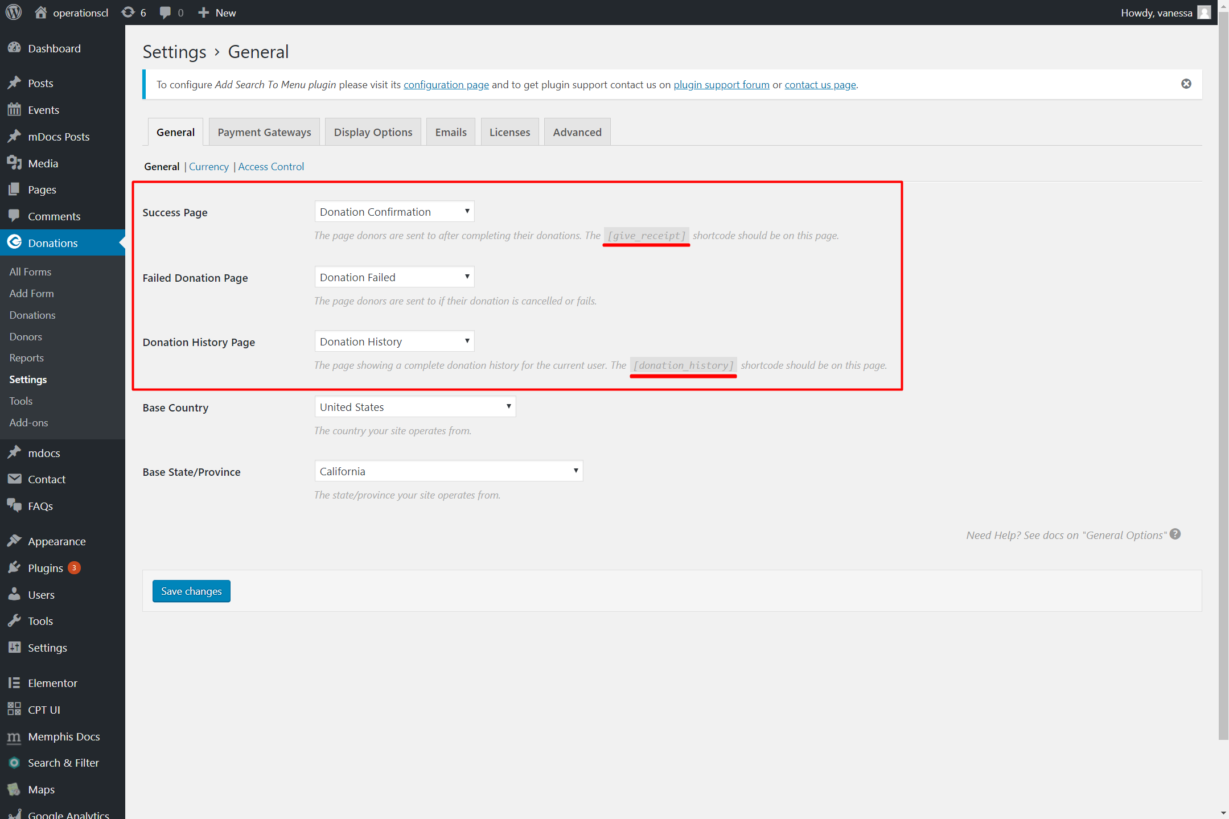

GiveSS03

# Adding Plugins to WordPress (cont.)

## Configuration (cont.)

### Give Donation Plugin (cont.)

Going to the *Payment Gateways* tab will allow you to turn test donations on and off (GiveSS04.png).

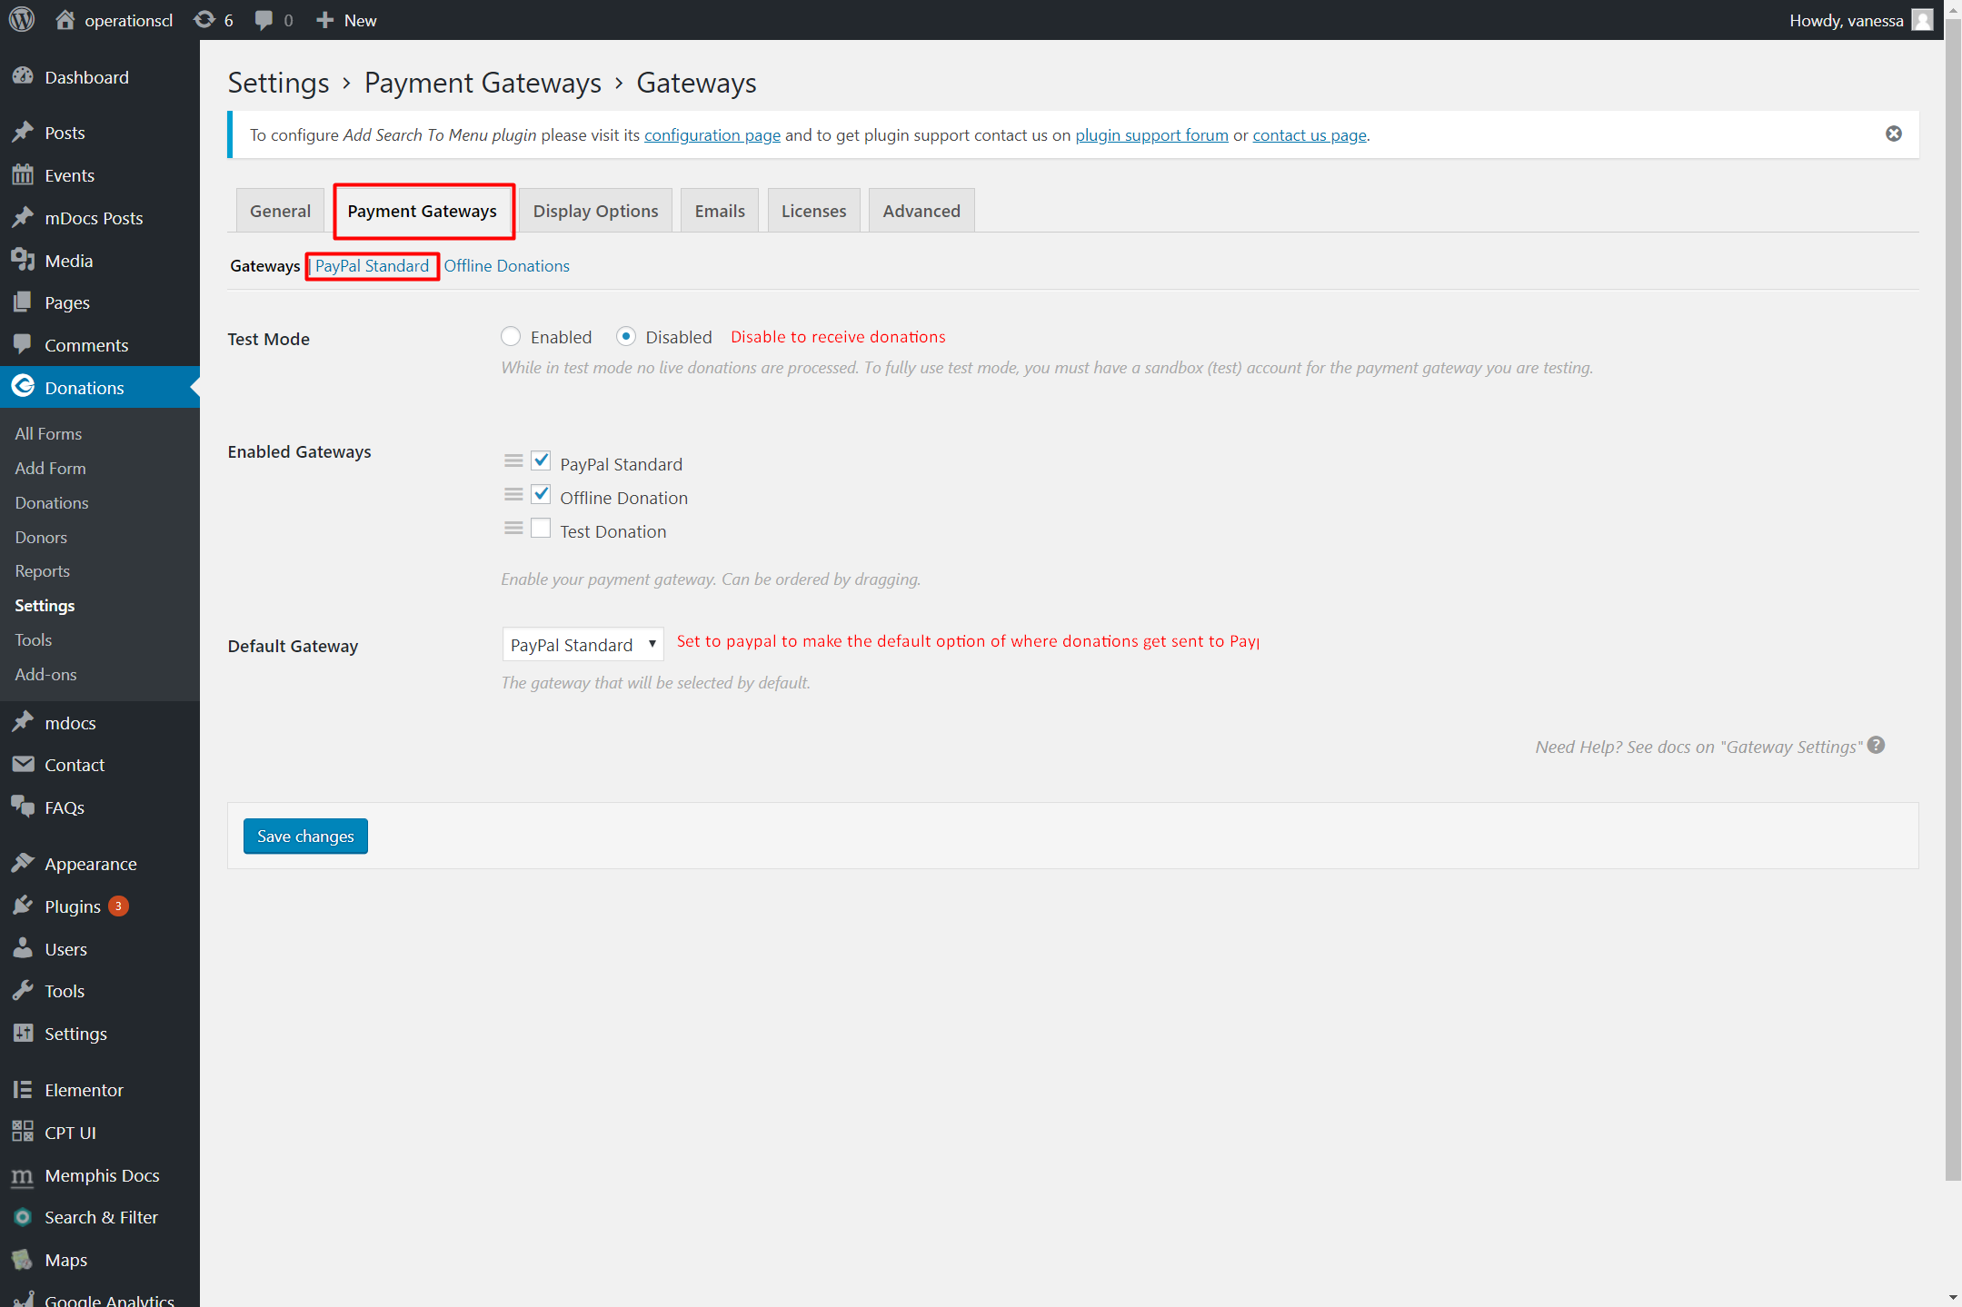

GiveSS04

# Adding Plugins to WordPress (cont.)

## Configuration (cont.)

### Give Donation Plugin (cont.)

The *PayPal Standard* tab is where you can input information about which PayPal account to send the money to (GiveSS05).

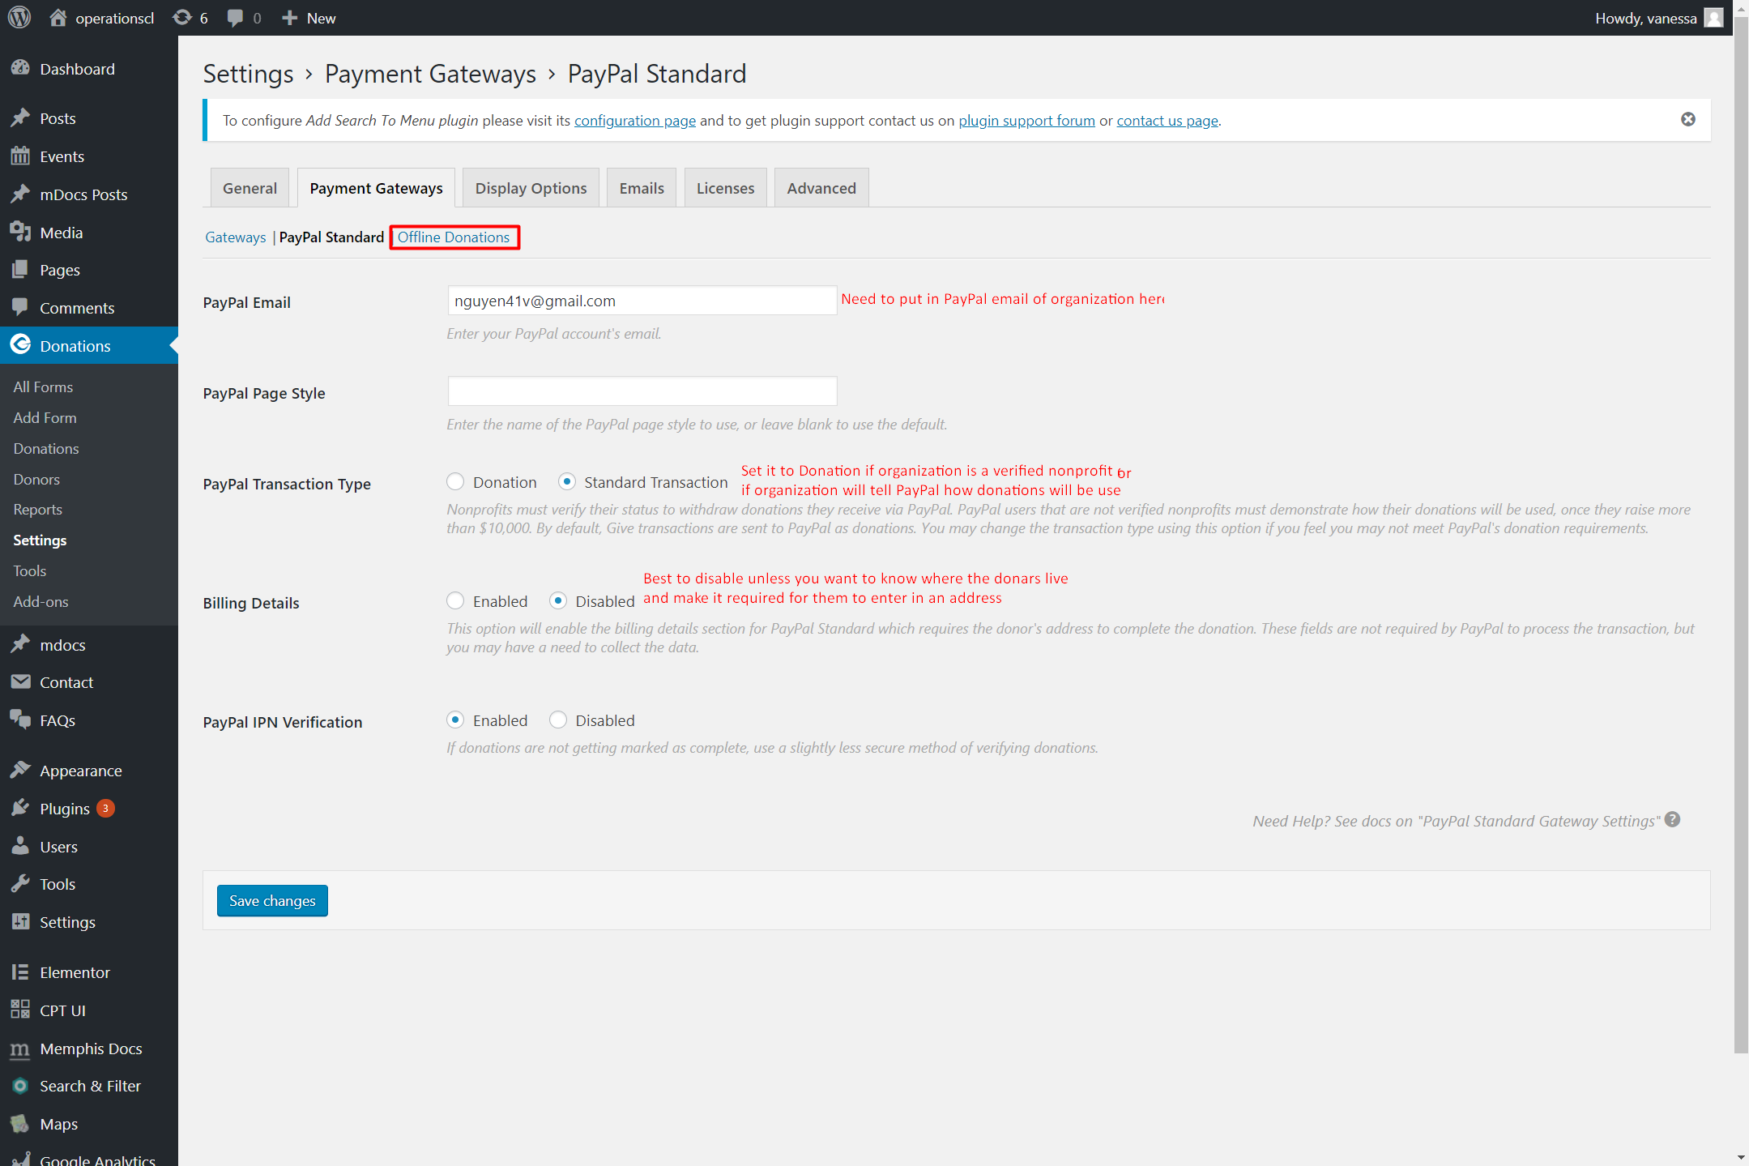

GiveSS05

# Adding Plugins to WordPress (cont.)

## Configuration (cont.)

### Give Donation Plugin (cont.)

The *Offline Donations* tab is where you can edit the message to give to donors if they want to mail in donations instead (GiveSS06).

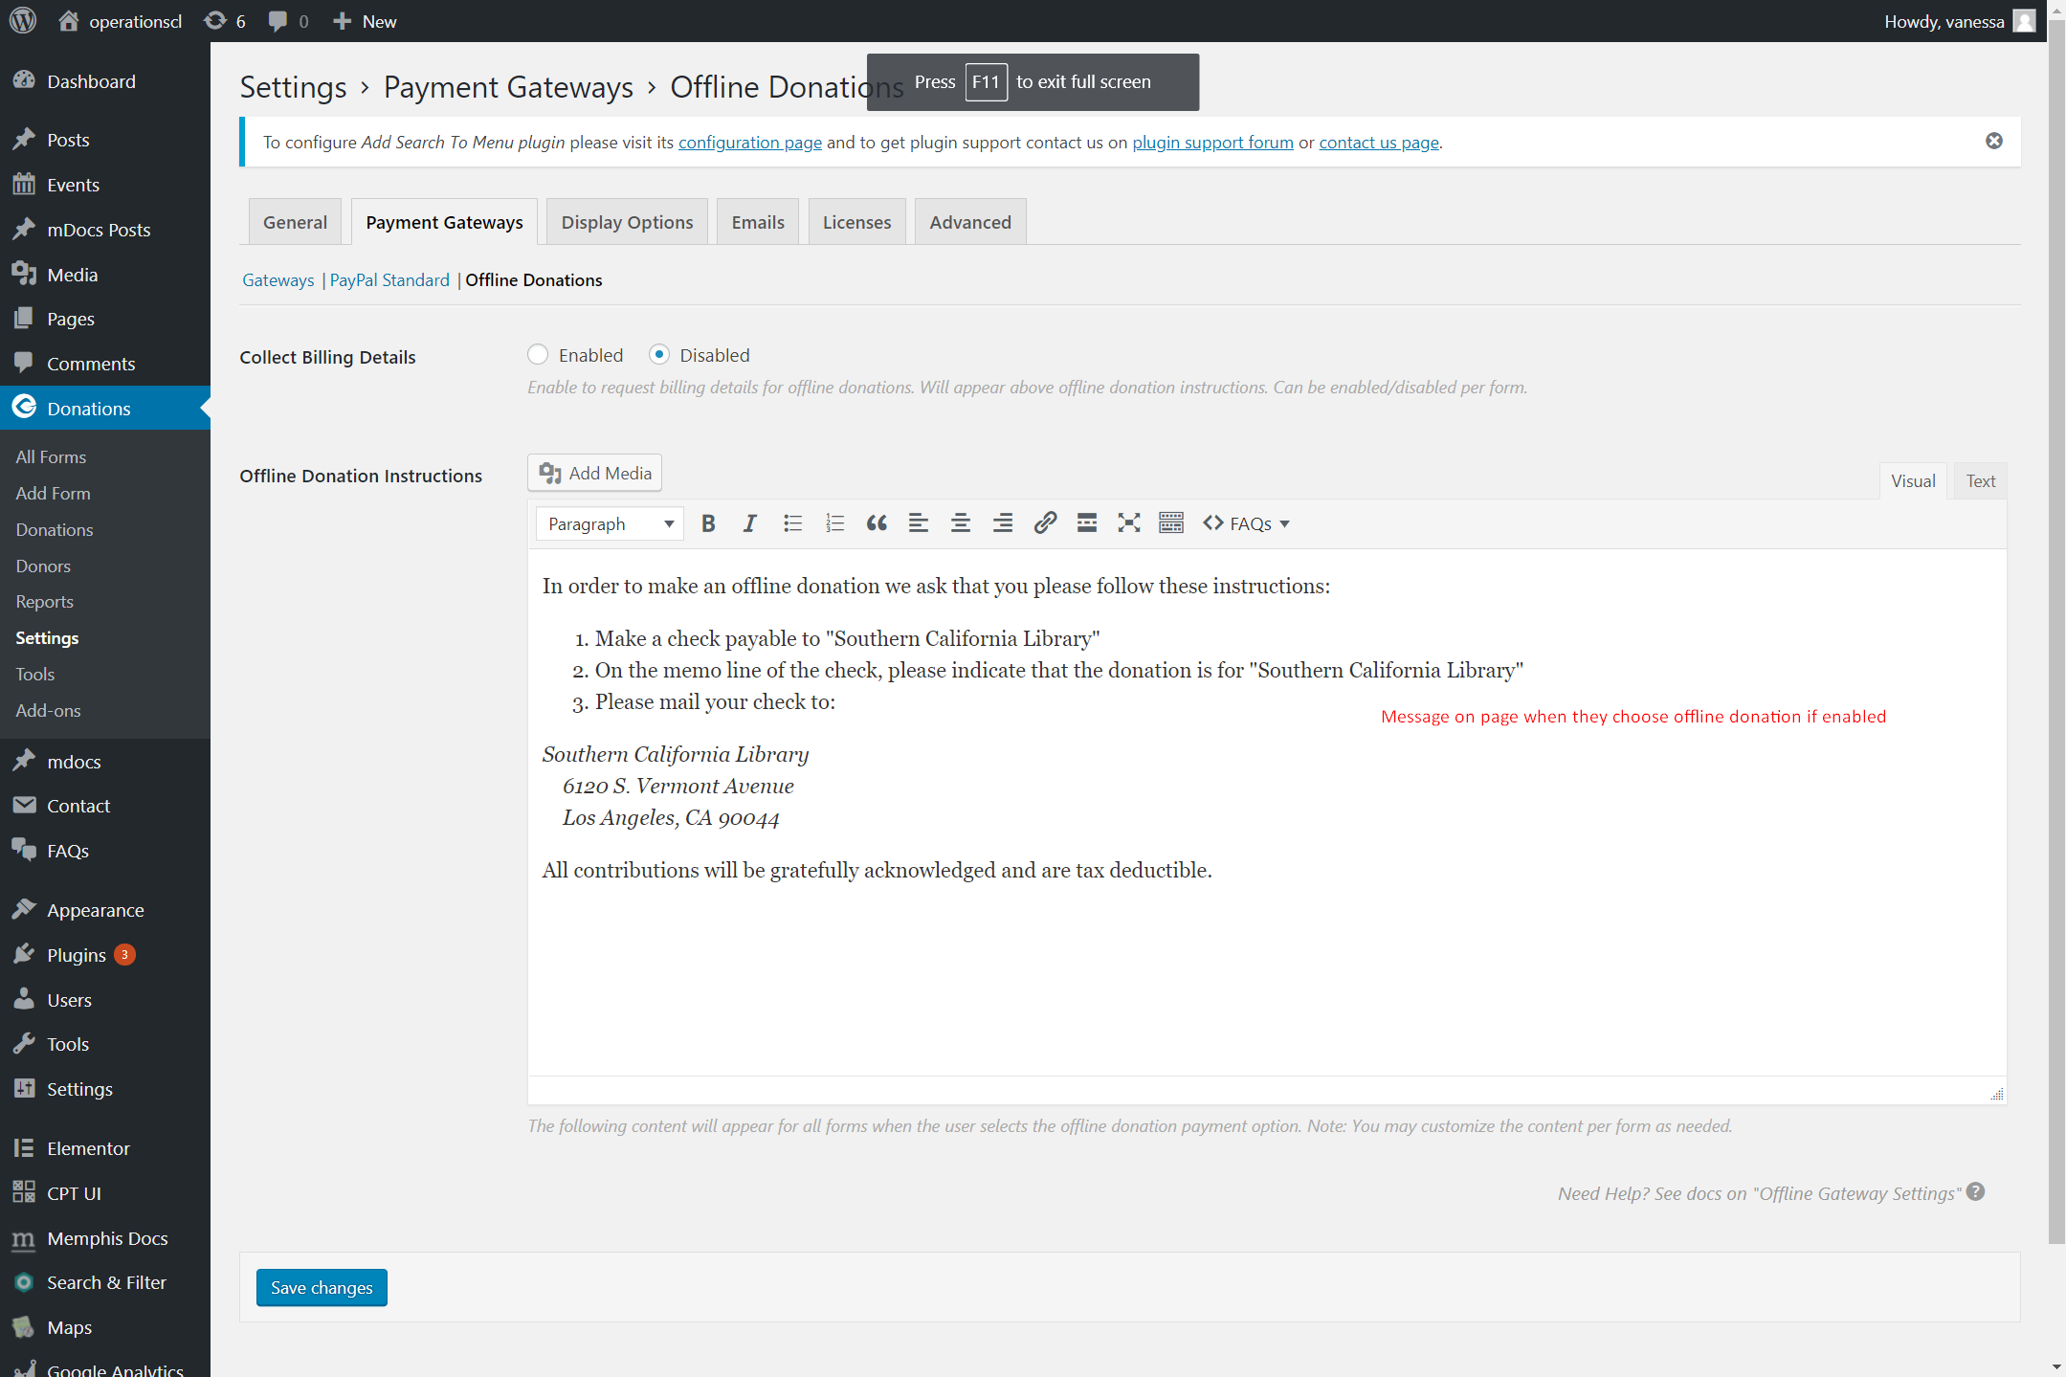

GiveSS06

# Adding Plugins to WordPress (cont.)

## Configuration (cont.)

### Google Analytics

# Adding Plugins to WordPress (cont.)

## Configuration (cont.)

### Memphis Documents

# Adding Plugins to WordPress (cont.)

## Configuration (cont.)

### Search & Filter